**Mega Man**

**-Solves Hospital Sanitation issues**

**CS590BD: Big Data Analytics and Apps**

**Instructor: Prof. Yugyung Lee**

**Project Group: PG2**

**Team Members**

**Rajashekar Kodimala – 28**

**Vamshi Kumar Reddy Guduru – 17**

**Prithvi Krishna Mannam – 35**

**Chandramouli Arumalla – 05**

**Motivation:**

The main motivation for our project design is the issues faced by hospitals these days on sanitary issues. Hospitals are facing many challenges for monitoring continuously in the hospital vicinity. In order to monitor continuously we have designed the robot, so that the robot will walk around the hospital to monitor for blood marks, syringes and all objects which are dangerous and needs immediate actions. Also our robot has the feature where it will take the snap of the blood and sends a message to the concerned authority to take an immediate action. Also the security is also a major concern in hospitals. So the robot can stay at the ICU and authorize the people who are entering into ICU.

**Related Work:**

We could find the robots working in the hospital to help patients to find their routes but we could not find any robots serving our purpose. It is entirely our own idea. We have also found out those robots which help in assisting the doctor during major operations. There are also very advanced robots which will replace doctor for very small surgeries which are still in research stages. Now many researches are going on especially about those robots which can replace the doctor and make man’s life easy. Our robot is a kind of robot which deals with the sanitary issues and will help in cleaning hospital floors and help to keep the patients away from some dangerous contagious diseases which can spread from the blood marks and other untidy and used stuff like syringes and cotton.

**Architecture:**

Spark

IOS

Android (Client)

User

**System Features**

**Interactive Communication:**

The robot takes the input from the user through android by converting the speech given the user to text and answers back to the user directly through speech. Some of the questions are “What is your name?”, “Do you know me?” What is the time?”,etc. This can be implemented with the help of Natural Language Processing. Here both text to speech and speech to text are implemented using google API.

**Weather Updates:**

The robot takes the input from the user using android through speech. When the user asks the question “What is the weather in Kansas City?”, then the robot replies with the weather which comes from the API implemented in IOS. Here we implemented the  Openweather API.

**Gesture Recognition:**

The robot can be controlled through gestures from the controller device. The robot gets the user’s gesture commands from android and will move accordingly. Here there is a socket communication between android and IOS. The robot can move in different directions according to the movement given by the user with the android. The robot moves in directions left, right, forward, backward and stops when given stop as speech from user.

**Colour and Blood Detection:**

Here when the robot is moving along the way and when it encounters a red color object it detects it and takes a picture of it. When a blood mark is identified in the picture, then the robot sends an SMS to the concerned authorities in order to take appropriate action. Here we are implementing colour detection where the robot takes the picture when a red colour is identified. We have used the OpenCV framework to detect the colour in IOS. Now we send the captured picture to the spark system where the image classification is done and informs the IOS if it is really blood mark. Than IOS sends message to the concerned authorities.

**Object Recognition:**

When the robot detects some objects like cotton or syringes, the robot takes the picture of it. And if the object is identified as cotton or syringe, then the robot will send an sms to concerned authorities about this. Here for Object detection we used OpenCV framework and implemented in IOS.

**Take a Picture:**

This is a feature which is implemented using Camera API and it is used whenever a red colour is identified or any objects like syringes or cotton is appeared. The robot uses the camera of IPhone to take a picture.

**Sing a Song:**

The robot takes the command from the user through speech and then plays a song which the robot is assigned to.

**Texting and Calling:**

This is a feature which is implemented to send an SMS to the concerned authorities whenever a blood mark or contaminated objects like cotton and syringes is identified by the robot. Here we have implemented TwilioAPI.

**Hospital Recommendation:**

This is a feature where the user asks for a recommended hospitals to visit. Then the robot replies with the top rated hospitals. Here when the user gives the input as “Recommend” through speech, then the IOS converts it into text and sends the word to the spark system. In the spark system we have implemented the Recommendation sytems which will return the top rated hospitals to the IOS. Now the robot replies back those hospital names through speech. Here the communication between spark and IOS is implemented using socket programming. In the spark system we have the dataset of all the hospitals and its rating by different number of users.

**Image Classification:**

When the robot identifies red colour or objects like cotton or syringe, the picture of it is taken and will be sent to the spark system. In spark system we implemented the image classification where we have a trained model and will detect the red blood mark or syringe or cotton and will send an alert to the IOS system where it is converted into speech and delivers to the user. In spark system we have trained the model with a large number of blood, cotton and syringe images and this helps to identify the test data whether there is actually any blood or cotton or syringe in the picture taken by the robot.

**Sentiment Analysis:**

Here the user wants the overall feedback of a particular doctor whether he/she is good or bad. The user will input the doctor name is given as input through speech. Then the robot will reply about the overall feedback of that doctor. The result might be “Doctor is good” or “Doctor is bad”. Here the speech of the user is taken by the robot and then it is converted into text and that text is sent to spark system. Here the sentiment analysis is done and then the output is sent to IOS and the robot speaks out that text. In the MongoDB we store the doctor along with the feedback or comments. The spark system picks the doctor and will perform sentiment analysis on the feedback. Then the output is sent to the IOS where the robot speaks out the output to the user through speech. But here we were not able to establish connection back to IOS which sends data to IOS. So we just implemented in standalone spark system where the data about doctor and his corresponding feedback is stored in spark data files and when we run this for a particular doctor the output will be overall feedback for the doctor in the spark console.

**Implementation**

We have implemented our project in three platforms: Android, IOS, and Spark.

**Android**

We have implemented the socket communication between Android and IOS for movement of the robot. We used some REST APIs and google APIs for robot movement on the floor and gesture recognition.

**IOS**

We have implemented the different features of robot like Text to Speech, Speech to Text, Texting, Calling, Color Detection and Object Detection using different APIs available in IOS, REST APIs and OPEN CV.

**APIs Used:**

1. Speech Recognition
2. Google Text to Speech
3. Speech to Text API
4. Camera API
5. Open Weather API

**Spark**

We used machine learning and streaming API of Spark for **image classification** of different images. In image classification we have prepared training data and test data for classification.

We implemented the **recommendations** using supervised machine learning.

We implemented the **sentimental analysis** using MONGO DB and Natural Language Processing. In MONGO DB we have stored all text documents required for sentimental analysis.

**Results/Evaluations**

**Image Classification**

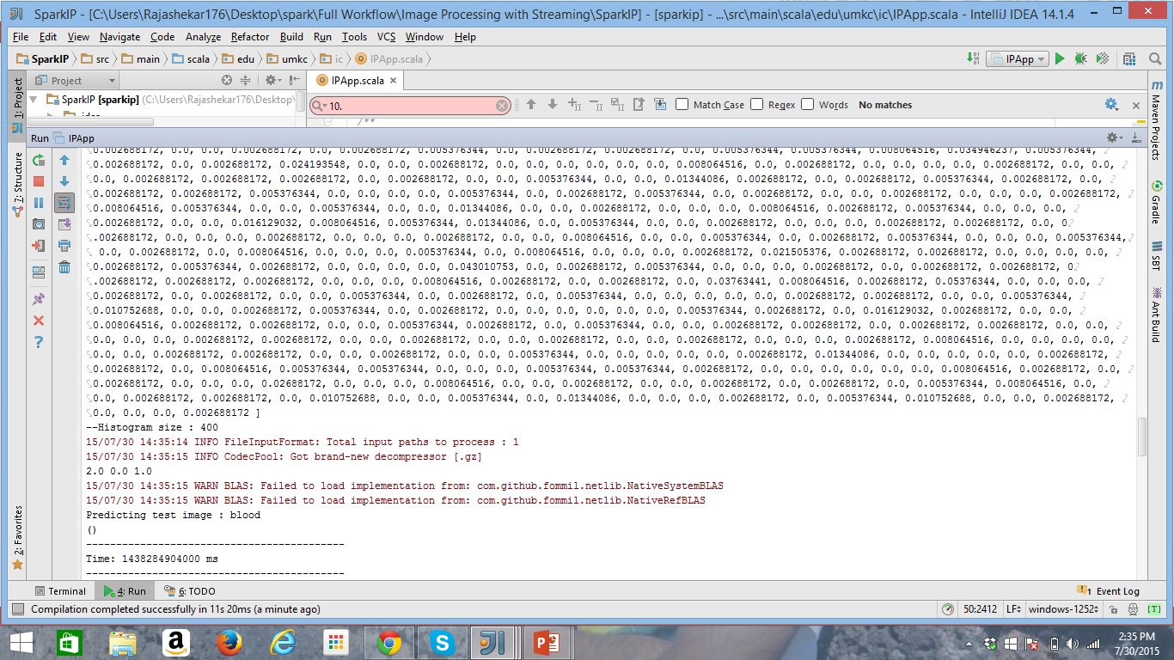

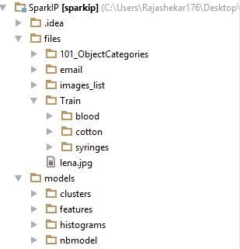

**Recommendations**

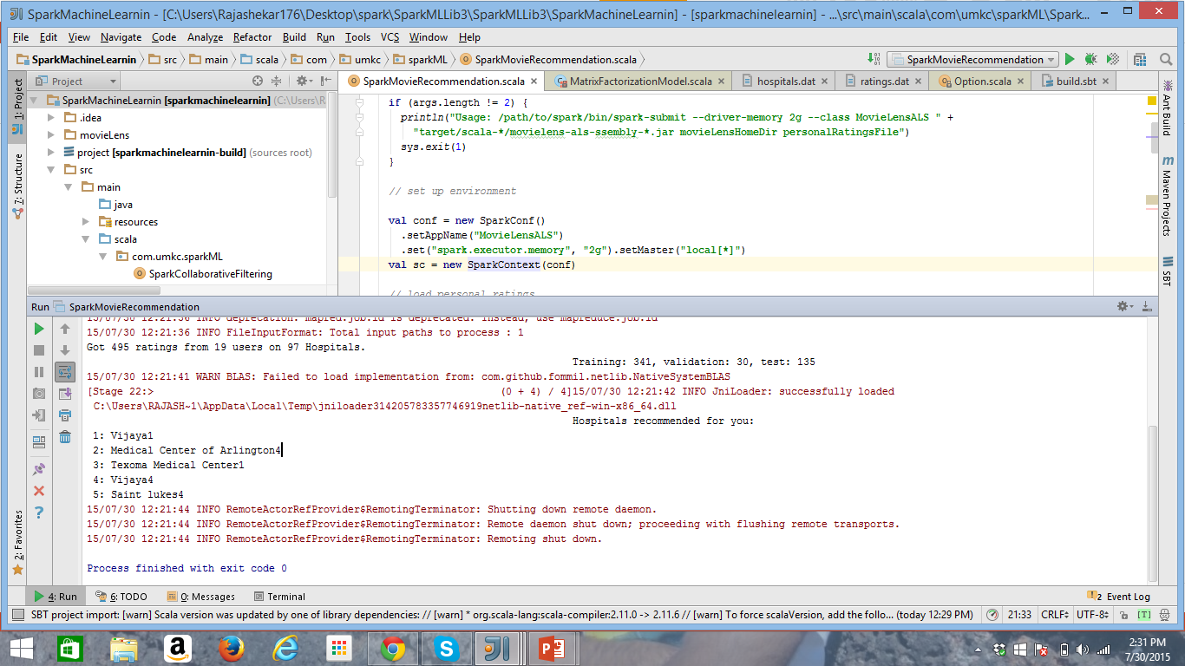

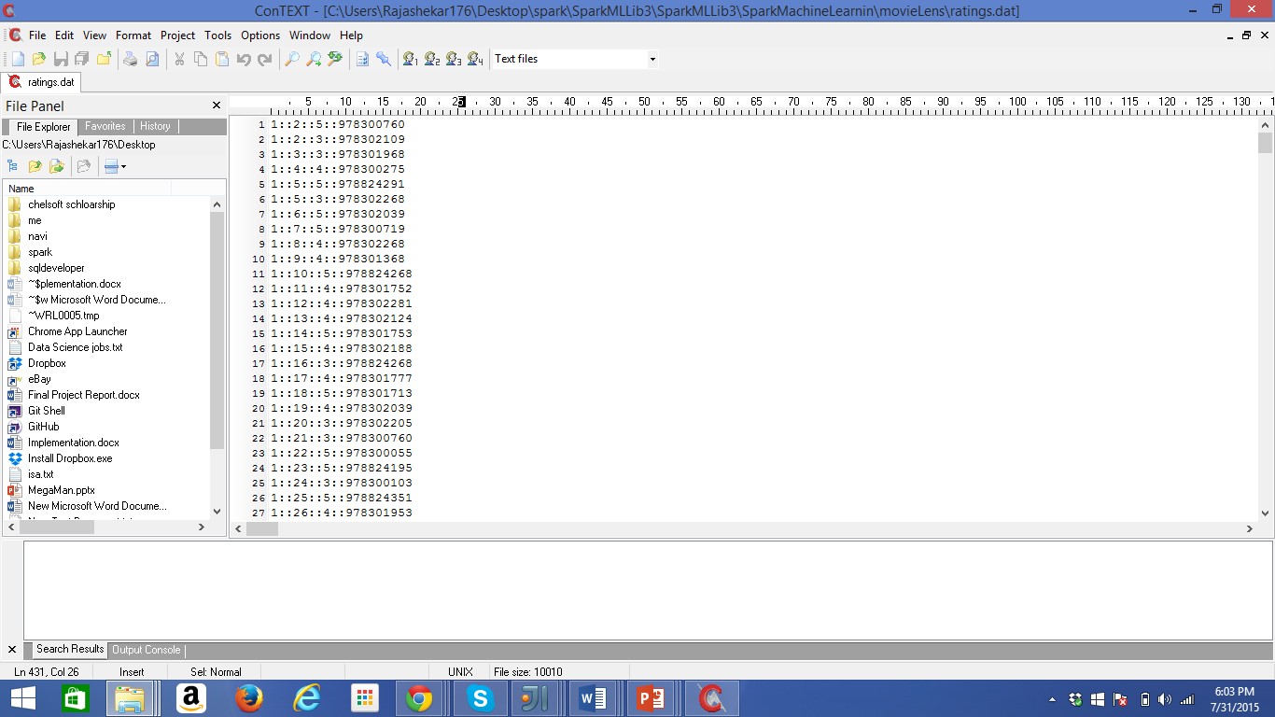

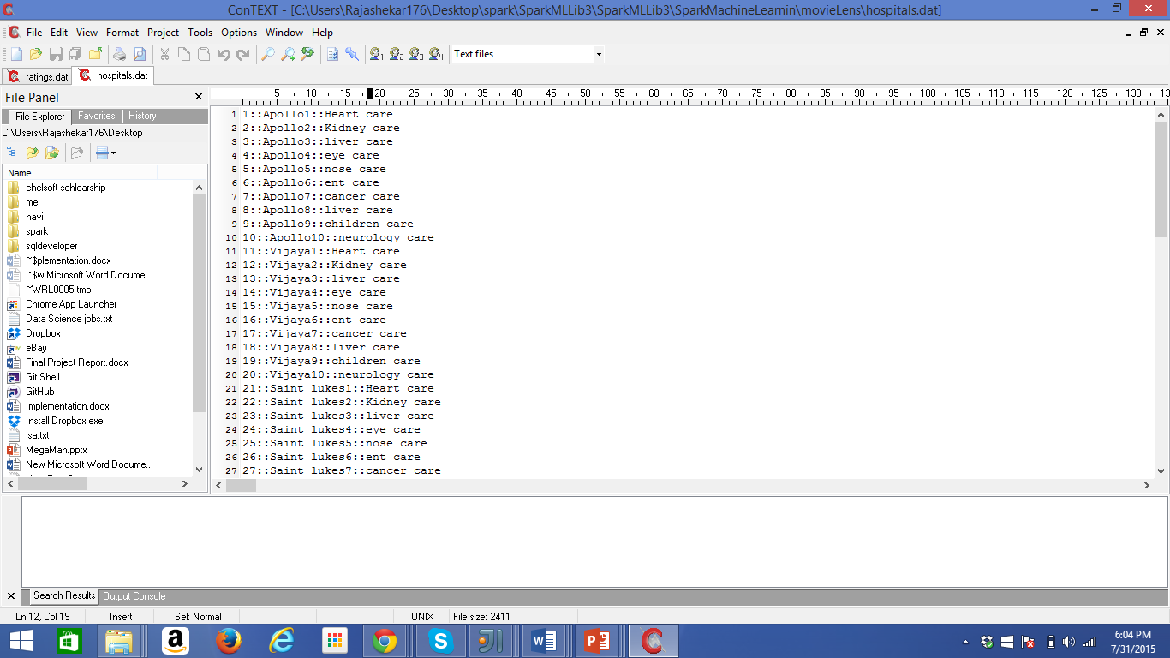

**Sentimental Analysis**

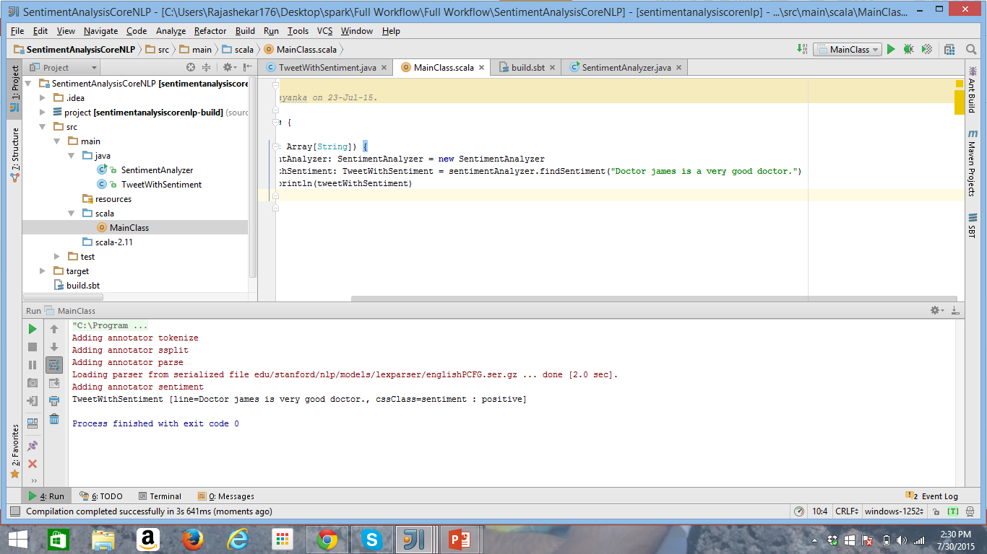

**Conclusion**

After working on various platforms and deploying the code on different environments, we have successfully implemented our project. For this we need to follow the software development lifecycle. First we have gone through requirements phase where we had to think about all the use cases and the way to integrate each and every feature in different technologies. Then we had to design it and implement. After this we had to deploy it in appropriate environments and test our application. This was done for each and every increment and finally we had to integrate all the features done in all the increments to build our final project. We have recorded the features of our robot and uploaded on youtube.

**Future Work**

1. In our project the robot will move only on one floor. In future we can extend the robot movement to whole hospital.
2. We can extend our robot as Hospital guide which can help the patients in the hospital.
3. Robot can recommend the diet to different patients based on diseases infected.
4. Robot itself cleans the floor after detecting the blood stain marks.
5. We can use our robot for security purposes in hospital using face detection.

**References**

<https://github.com/apache/spark>

We have referenced all the spark material from the above link. We have applied Image analysis, recommendations from here

<http://opencv.org>

We have implemented object recognization using the help of OpenCV.

<https://www.twilio.com>

We have used this for implementing SendSms feature for the robot

<http://openweathermap.org>

We have used this app for getting the weather alerts.

<https://github.com/xcatsan/iOS-Sample-Code>

we have used github for all the Ios coding, API and implementations.